## **Step 1 – Select the document -** Click the name of the document you would like to sign

## 

## 

## **Step 2 – Download the form –** click the save icon in the upper left-hand corner to save a copy of the form to your computer.

## 

## **Fill in the Form –** Open the saved form and fill in the form by clicking the desired text boxes.

## 

## **Step 3 – Apply your signature –**

## The easiest way is to use the fill and sign feature. To do this first click the **“Fill & Sign”** tool in the right pane.

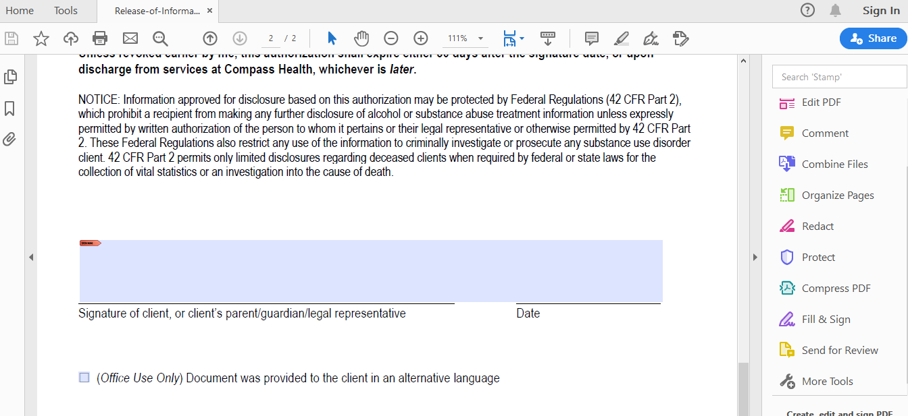

## Signatures can then be applied by clicking the **‘Add Signature’** option in either left side menu or the larger fill & sign menu

## Select the **‘Draw’** option to create your signature. The **‘clear’** button on the right side can be used to delete the signature if a mistake is made.

## Select **‘Apply’** and then add the signature to the document.

## After selecting **‘Apply’** move your mouse to the location where you’d like to place your signature and click once to place your signature. To reposition the signature, click and drag the left-edge of the bounding box.

## 

## To change the size of the signature, click and drag the handle on the bottom-right of the bounding box, or click one of the A icons in the blue context menu.

## Note: When you save a form with a signature or initials, you will no longer be able to edit the existing form fields.

## The other way to apply a signature that is accepted by compass health is by clicking the little red signature label at the top left hand corner of the signature box

A popup window will ask which digital ID you’d like to use to sign. You may use an existing signature by clicking **‘Continue’** or you can create a new one by selecting the **‘Configure New Digital ID’** option.

## A screenshot of a computer Description automatically generated with medium confidenceSelect **‘Create a new Digital ID’** and then **‘Continue’**

## Select **‘Save to File’** and then **‘Continue’** again.

## A screenshot of a computer Description automatically generatedThen enter your name and email address, select **‘Continue’**.

## Create a password to protect the Digital ID and then confirm the password.

## A screenshot of a computer Description automatically generated with medium confidenceYour new Digital ID should be available to select **‘Continue’**

## Enter your Digital ID password and select **‘sign’**

## When finished, click the **‘Save’** icon located in the top left-hand corner of the screen.

## 

## - Please save the file as a PDF

## **Step 4 – Submitting the Forms**

## Go back to the Compass Health Client Forms website. To submit the form either click the **‘Select Files’** button to select the file you’d like to upload or drag and drop the file into the screen and then click the **‘Submit’** button to finish.

## 