Tip Sheet – Release of Information (ROIs)

IMPORTANT NOTE:

Your medical information is protected. An ROI lets us talk to other people (doctors, schools, treatment agencies, etc.) who have taken care of you. We usually ask for information from the last 5 years. The ROI lets us send and receive information to provide better care for you.

ROIs can do up to three things: (usually you want Compass Health to exchange)

- Allow Compass Health to share information about you to someone (such as a caregiver, natural support, family member, or someone involved in your care like your doctor/PCP). This type of action is called disclose.
- Allow someone else (such as a hospital, school, or previous mental health treatment providers) to share information about you with Compass Health. This type of action is called receive.
- Allow Compass Health to send and receive information about you, an exchange of information (such as between Compass Health and your doctor/PCP). This type of action is called exchange.

- Key factors to remember:
  - ROIs expire when you leave treatment, or if you revoke/end the ROI – Clients can revoke or end an ROI at any time.
  - In an emergency or a situation in which your safety or the safety of someone else is at risk, information about your health or medical records can be released without an ROI.

To complete the ROI form please fill out the required sections:
- Client Name/ID/DOB – Please include the client’s first name, last name, and date of birth in this section.
- Compass Health Address: This area should already be prefilled with the Compass Health’s Health Information Management address, but if not, please fill it in with this information:
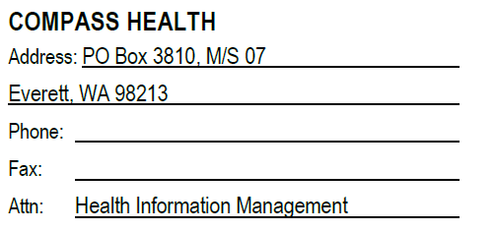
- Mark what Compass Health can do: either disclose, receive, or exchange information. List the name of the person Compass Health can talk to about you. This can be a person such as your emergency contact or someone that has helped you in your past such as your PCP, or a hospital, or a school.
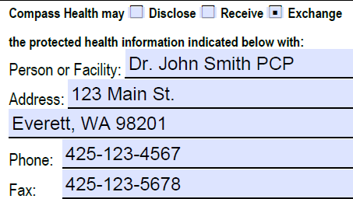

- Please select All Dates. If you do not want to share old information you can add a date range. If you add a date range we will only be able to share information about you from these dates.

- Select the types of documents/information you would like to be shared
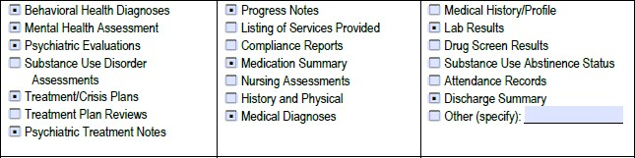

- Indicate at least one reason for disclosure – usually coordinating care/service delivery
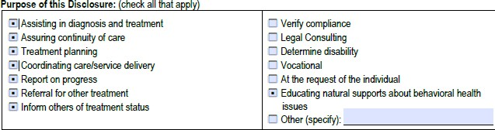
- To disclose information related to HIV/AIDS or sexually transmitted diseases select the approve box.

- Add the date the ROI is effective – usually this would be today’s date.

- Lastly, sign and date the ROI
- We accept PDF signatures that are drawn out using the mouse/finger or signatures that say “digitally signed by…”. We do not accept typed names with changed font style as a signature.
Ok! | Ok! | Not ok!
 | 